# PRECISION AGRICULTURE USING MACHINE LEARNING

Softwares Used:

* Programming Language

Python3

* Front-End

HTML, CSS, JavaScript, Bootstrap, Python-Flask

* Back-End

MySQL

* Python-Libraries

Seaborn, Pandas, NumPy, SciKit-Learn, Pytorch, ResNet-9, SQLAlchemy, Pickle

Algorithms used & their accuracy:

|  |  |
| --- | --- |
| **Algorithm** | **Accuracy (%)** |
| **Decision Tree** | 90% |
| **SVM** | 97% |
| **Logistic Regression** | 95% |
| **Random Forest** | 99% |

User Interface Snap:

**Home Page** 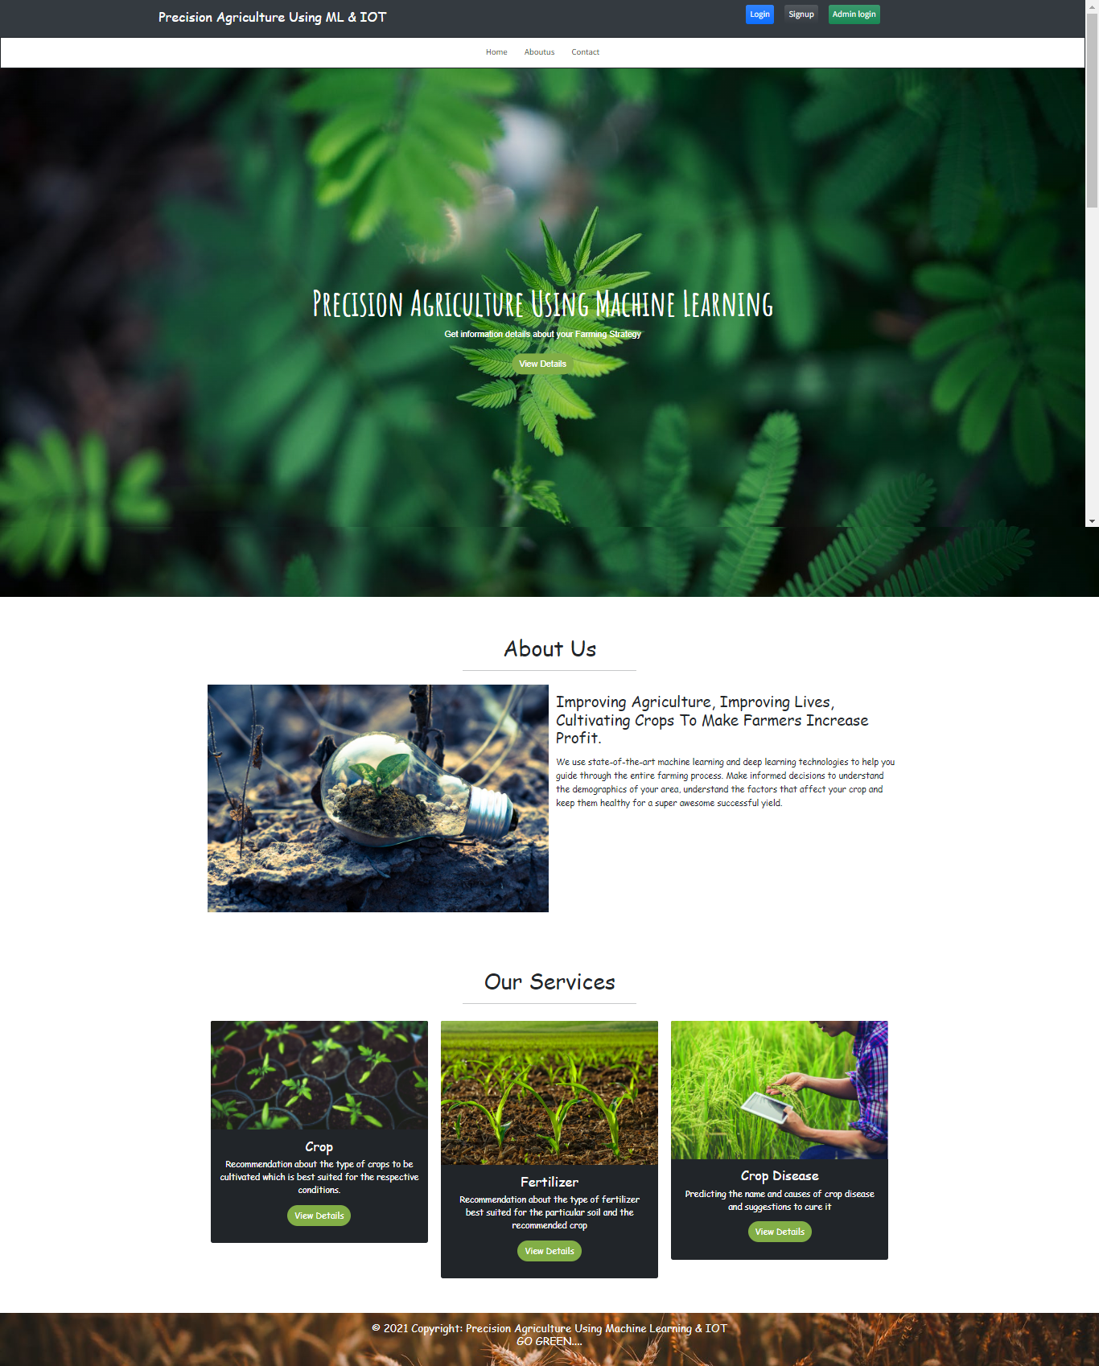

**Crop Recommendation & Result Page** 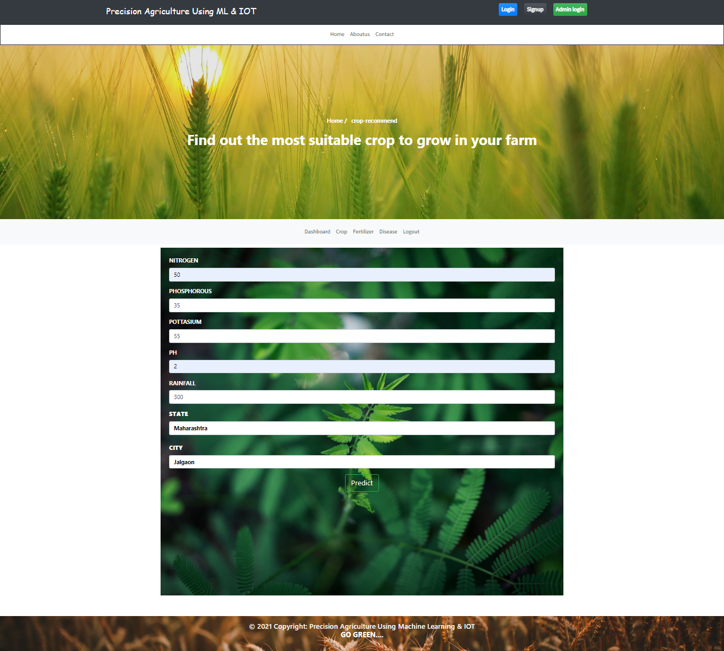

**Result** 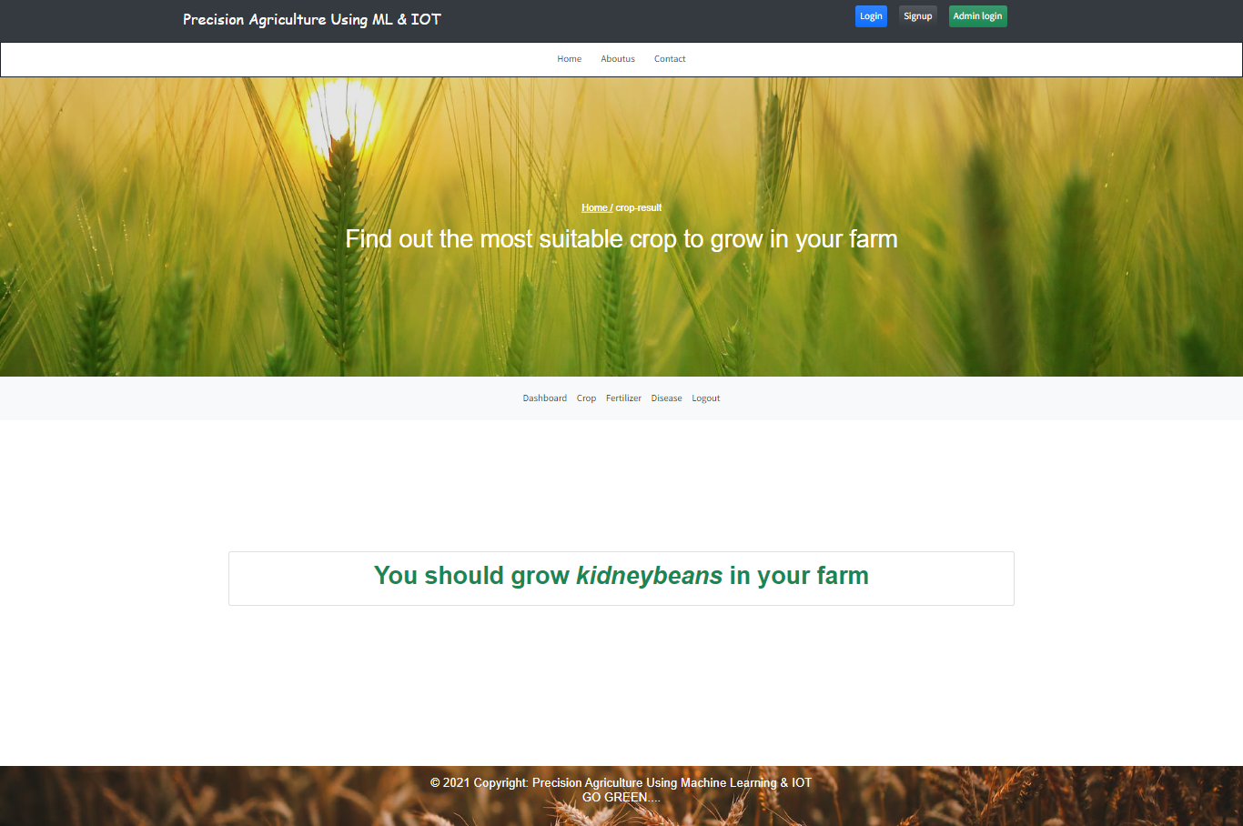

**Fertilizer-Suggestion & Result Page**Crop 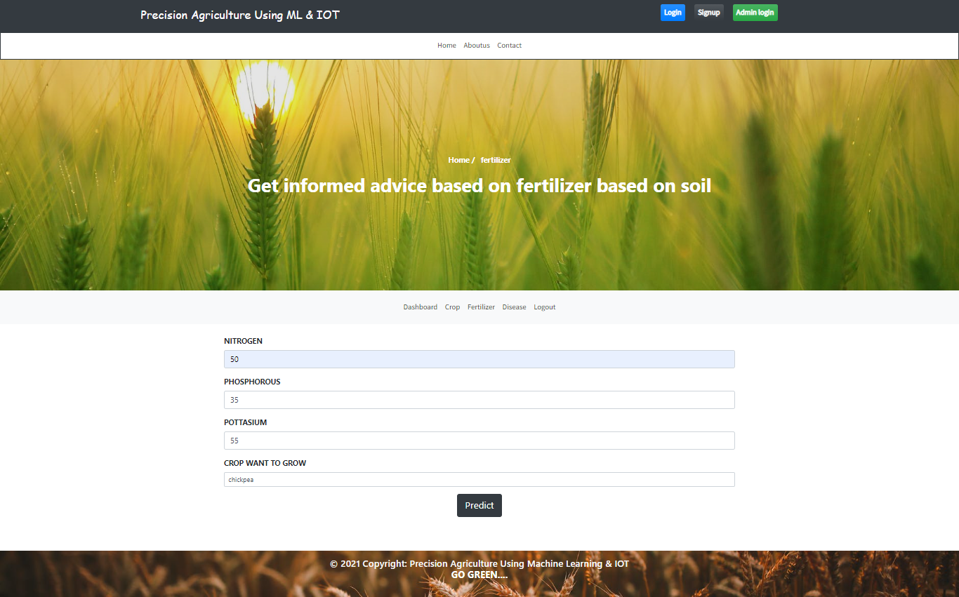

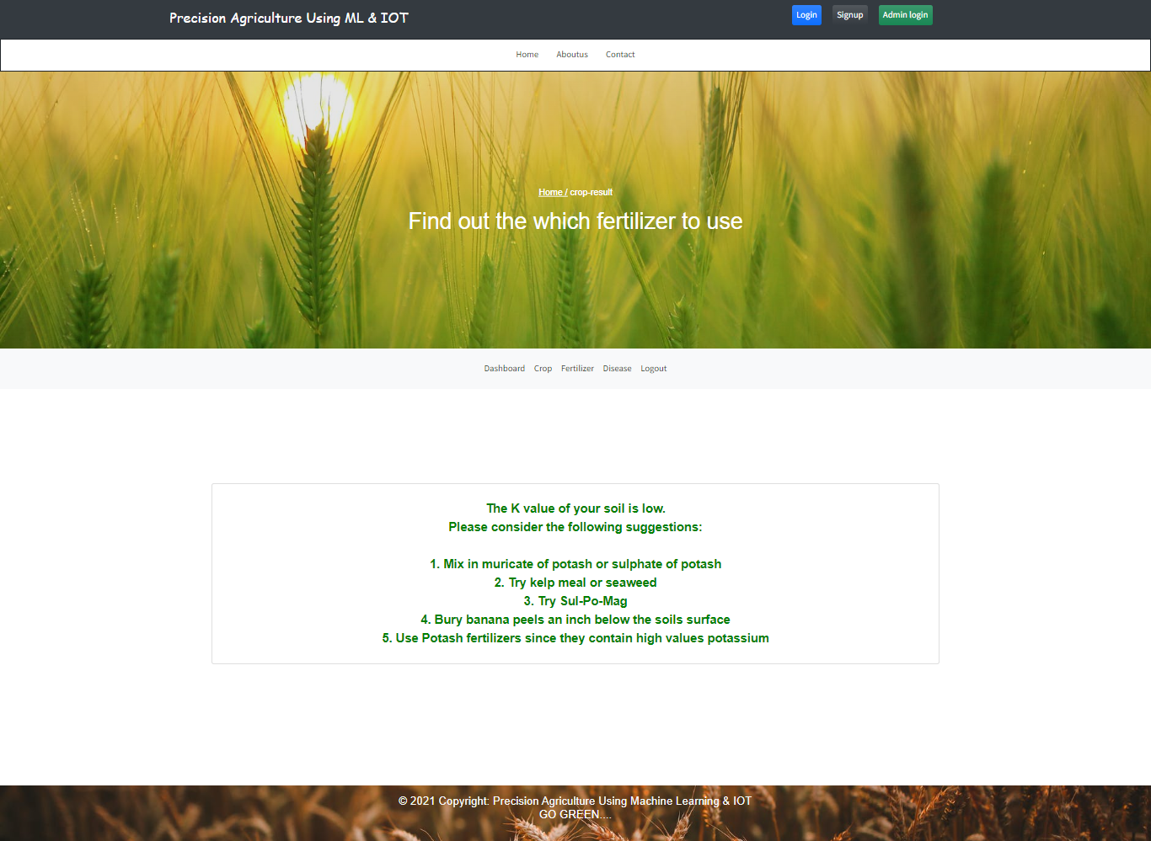

**Crop Disease Prediction & Result Page**Crop 